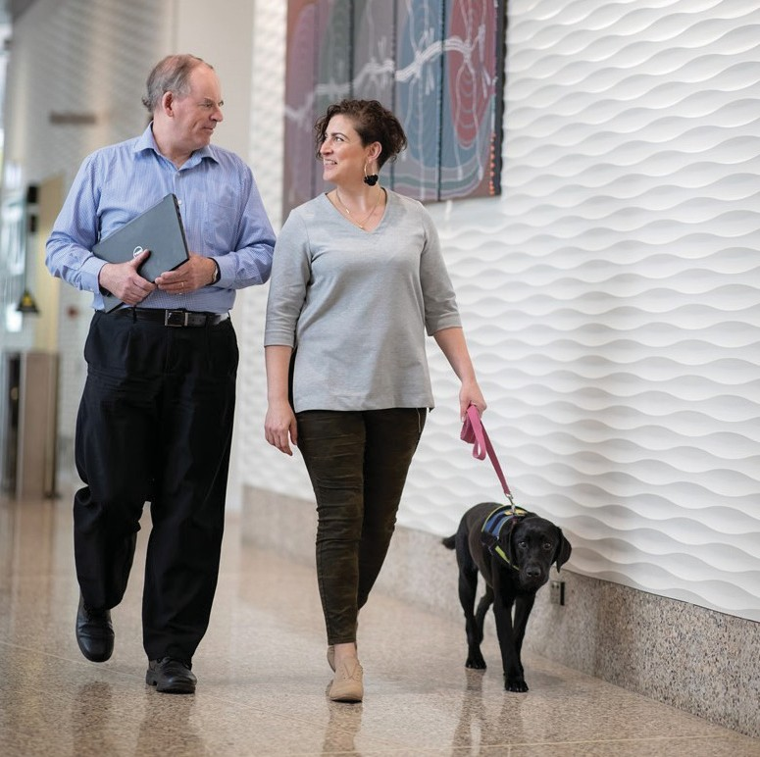

Accessibility
Inclusion Plan

Accelerating Accessibility Inclusion
for Melbourne Water 2018 – 2021

 | 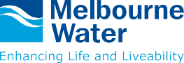

Message from the Managing Director
At Melbourne Water, we are committed to creating an inclusive workplace culture, and achieving a diverse workforce that includes employees with a lived experience of disability. Our vision is enhancing life and liveability.
While we do this every day through the delivery of essential water services for our customers, we recognise that our vision does not discriminate and we need to ensure that for people living with disability, or carers of someone with disability, we continue to offer equity and inclusion.
We acknowledge that approximately 1 in 5 people in Australia have a disability, and we recognise that we have an important role to play in supporting and enhancing the life and liveability of not just those people, but also the carers and support networks. Many people with disability have experienced unfair disadvantage.
Disability is relevant to every aspect of our business – our customers, our employees, our communities, our suppliers and our key stakeholders – and I am proud that this Accessibility Inclusion Program furthers our vision of enhancing life and liveability in every area of our business.
In 2016 we commenced our two year Accessibility Inclusion Plan. The purpose of that plan was to create positive awareness of people with disability. This plan has been successful in laying some important foundations, ensuring that we can now make significant steps towards achieving authentic accessibility inclusion.
I look forward to reporting on the implementation of these initiatives as we progress.

Michael Wandmaker
Managing Director


Vision for an accessible Melbourne Water
Melbourne Water’s vision is enhancing life and liveability. We do this by delivering essential water services, desirable urban spaces and protecting our natural environment for future generations.
We recognise that actively creating and supporting diversity and inclusion not only helps us to achieve our purpose, but also helps us to attract and retain high calibre talent, increasing our capacity for high performance, and better understand our customers’ needs. Being an accessible organisation is the right thing to do.
Melbourne Water is committed to valuing and supporting individual differences and creating an environment where everyone can fully contribute to realise their full potential. We want to be an organisation that genuinely supports inclusion of people with disability, that embraces different perspectives and supports all our people to achieve fulfilling careers and lives.
We know that not all disabilities are visible, that some people have had disability from birth, while some will acquire disability while working at Melbourne Water, while others may support a person with disability. In our last Diversity Census (2018), 7% of respondents identified as living with disability, while a further 3% identified as caring for someone with disability. People with disability can and already do make a significant contribution to Melbourne Water and the wider community.
We know the important role that people with disability play in our community and in our organisation. We also recognise that in order to best support inclusion, we must continue to review and implement organisational change
which enables Melbourne Water to be accessible to all. We will be deliberate and specific in taking action toward genuine inclusion, moving beyond compliance.

Where do we want to get to?
- By 2023, 15% of employees identify as having disability
- Build our inclusive culture through increasing employees’ knowledge and understanding of disability, and their ability to identify and remove potential barriers to participation
- Increase the accessibility of Melbourne Water managed goods, services and facilities
- Promote inclusion and participation in the community of people with disability

About the Accessibility
Inclusion Program
This Accessibility Inclusion Program has an emphasis on employment – both direct (e.g. recruitment) as well as indirect (e.g. procuring services from social enterprises) for individuals with disability. While people with disability make up almost 20% of the population, more than 50% of those with disability are unemployed. Research shows that people with disability tend to:
- Take fewer days off, take less sick leave and stay in jobs for longer than other workers
- Have fewer compensation incidents and accidents at work compared to other workers
- Be more affordable, as recruitment costs are often lower
- Build strong relationships with customers
- Boost workplace morale, enhance teamwork and contribute to high performance and innovation.

Context
Four million people in Australia (18.5%) report having disability, according to the results of the national Survey of Disability, Ageing and Carers (SDAC). This survey was conducted in 2009 by the Australian Bureau of Statistics.
Disability is defined in this plan as any limitation, restriction or impairment which restricts everyday activities and has lasted or is likely to last for at least six months.
Disability includes any or a combination of sensory, physical, intellectual, development delay or neurological impairment, or acquired brain injury that causes a substantially reduced capacity in at least one of the areas of self-care, self-management, mobility or communication and requires significant ongoing or long-term episodic support.

Legislation and policy



International
The Convention on the Rights of Persons with Disabilities was adopted by the United Nations in 2006 and open for signature on 30 March 2007. There were 82 countries as signatories which is the highest number of signatories on an opening day in the history of UN Conventions.
Australia is a signatory to the Convention that reaffirms that all people with all types of disability must enjoy all human rights and fundamental freedoms.

National
The Disability Discrimination Act 1992 (‘DDA’) provides protection for everyone in Australia against discrimination based on disability. The DDA makes it unlawful to discriminate in the provision of goods, services or facilities against people on the basis that they have, or may have, disability. It is also unlawful to discriminate on the basis that a person has or may have associates with disability.
The National Disability Insurance Scheme Act 2013 establishes the framework in which the National Disability Insurance Scheme operates and gives effect to certain obligations under the Convention on the Rights of Persons with Disabilities.
The National Disability Strategy outlines a 10 year national policy framework to guide government activity across six key outcome areas and was endorsed by the Council of Australian Governments (COAG) on 13 February 2013.

State
The Disability Act 2006 provides for a strong whole of government, whole of community response to the rights and needs of people with disability and established a framework for the provision of high quality services and supports for people with disability.
The Disability Act 2006 also established the Disability Services Commissioner who provides a free and accessible process for resolving complaints. Under the Equal Opportunity Act of 2010, it is against the law to discriminate against a person on the basis of disability and carer status, along with personal association with someone who has, or is assumed to have, any of the characteristics listed within the act.
The Victorian Equal Opportunity and Human Rights Commission have also outlined their commitment to the elimination of discrimination against people with disabilities, and have outlined their plans within their own Disability Action Plan. A key objective within this plan is to reduce barriers to obtaining and maintaining employment.
The Victorian Government understands that people with disabilities, like all members of the community, should have access to a range of programs, services, facilities and employment opportunities that support quality of life.
This Accessibility Inclusion Program will drive Melbourne Water to continue identifying and, with a sense of courage, remove significant barriers to ensure that our employees and stakeholders have the best opportunity to be part of the Melbourne Water community.
Melbourne Water will report the implementation of its Accessibility Inclusion Program annually as consistent with Section 38 of the Disability Act 2006.

About Melbourne Water

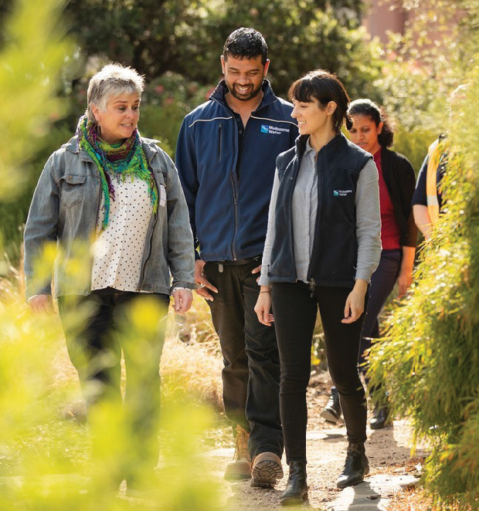
Melbourne Water is owned by the Victorian Government and has provided safe, secure and affordable water services to Melbourne for over 125 years.
We treat and supply drinking and recycled water, remove and treat most of Melbourne’s sewage, and manage waterways and major drainage systems in the Port Phillip and Westernport region. In doing so, we strive to deliver solutions that are financially and environmentally sustainable and achieve the best outcomes for the community.
We value strong relationships with our customers and stakeholders in the community, government and industry, and care for the health and wellbeing of our people – which includes nurturing a diverse workforce and inclusive working environment.

Governance of accessibility at Melbourne Water
A member of the Senior Leadership Team sponsors and chairs the Accessibility Working Group made up of managers responsible for implementing actions to progress accessibility inclusion. Management representatives (at a minimum) cover the following accountabilities:
- Facilities management
- Community engagement
- Digital engagement
- Information technology
- People and capability
The General Manager, People and Capability has overall responsibility for the development and implementation of the Accessibility Inclusion Plan, and reports progress to the People, Safety and Remuneration Committee of the Board on a quarterly basis.
The Diversity and Inclusion Team, led by the Diversity and Inclusion Manager, also play a role in advising and delivering on the actions within the Accessibility Inclusion Plan (and other diversity action plans and the Diversity and Inclusion Strategy). This includes:
- One member of the Diversity and Inclusion team will participate in and regularly attend meetings with the Accessibility Working Group.
- The Diversity and Inclusion team will advise on best practice initiatives and will act as a conduit to external advisory services, including Australian Network on Disability and other external services such as Vision Australia.
- Ensuring alignment in actions between the Diversity and Inclusion Strategy (2016-2020) and the Accessibility Inclusion Plan (2018-2021)
- Support and deliver specific actions that they are accountable for within the Accessibility Inclusion Plan (2018-2021).
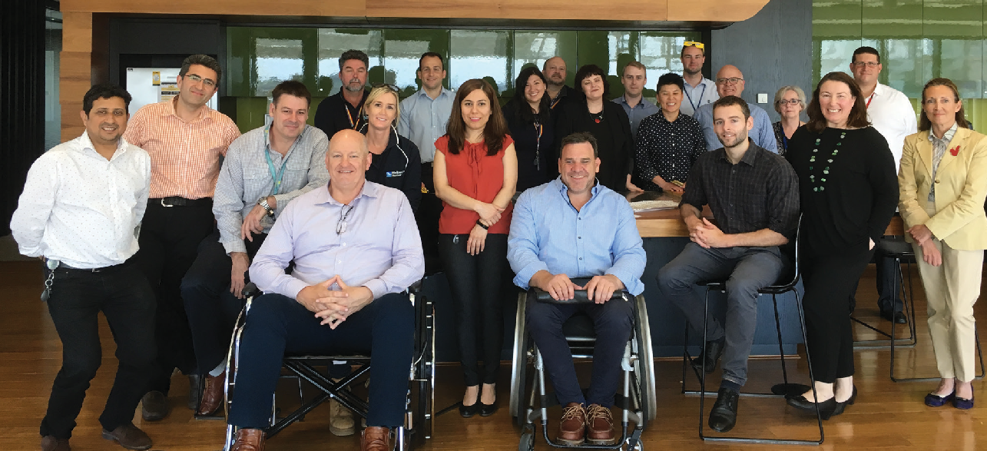

Disability Advocacy Network
Melbourne Water’s Disability Advocacy Network is made up of employees with a lived experience or strong interest in disability. The network is a resource for individual employees and the organisation. As an intrinsic element of delivering Melbourne Water’s Accessibility
Inclusion Plan, the network advises and supports the work of the Accessibility Working Group. It is expected that Melbourne Water leaders will enable employees to participate in the Disability Advocacy Network.
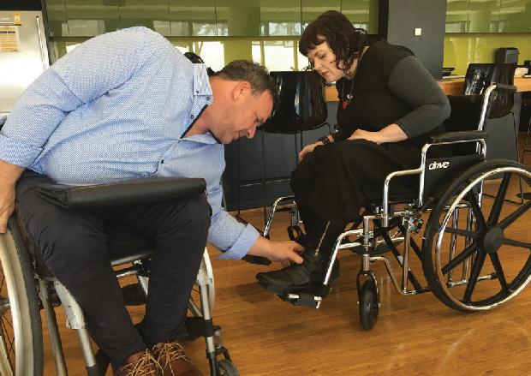

Purpose
- Points of contact and guidance for employees
Network members are points of contact for employees and contractors looking for guidance or support about disability in their lives.
- Advocacy, advice and awareness building for the organisation
The network as a group:
- advocates for the needs of employees living with disability or caring for someone with disability
- advises the Accessibility Working Group on Melbourne Water’s Accessibility Inclusion Plan and its implementation
- initiates, promotes and supports People and Capability to organise activities that build the organisation’s and employees’ awareness of the experiences of people with, or caring for some with disability

Accessibility Inclusion Program
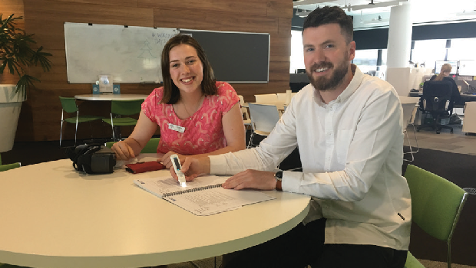
In developing this Accessibility Inclusion Program the Accessibility Working Group sought advice from Matthew Parker on the principles that have been used to develop the program.
- Evidence based approach – engage with current employees and experts
- Internal and external focus – employer and service provider
- Consultation on implementation – involve experts in guiding the delivery of disability actions
- Be bold and courageous – use a centre piece to drive action
- Disability inclusion basics – include information on legislative obligations
- Employment opportunities – have specific targets and programs
- Premises and technology – aim for full accessibility
- Leadership commitment – importance of accountability, transparency and regular performance reporting to senior executives.

Approach
The program logic used to manage accessibility consists of setting outcomes, identifying actions, setting deliverables, tracking progress and formal review.

Setting outcomes
Outcomes describe the result of progress toward accessibility inclusion. The previous Accessibility Inclusion Plan 2016-2018 identified 4 outcome areas that have been built on.

Identifying actions
The previous Accessibility Inclusion Plan 2016- 2018 identified 16 actions to achieve the outcomes, 10 of which were fully actioned and 6 which were partially actioned. The actions in this Accessibility Inclusion Program build on the actions and intent of the previous plan.
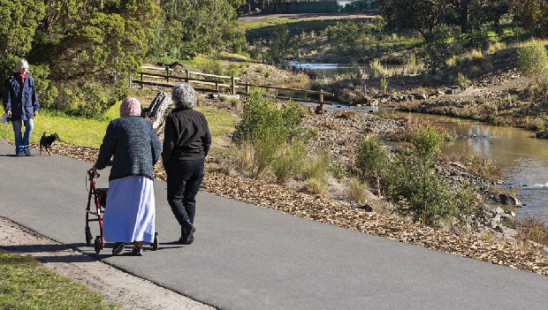

Setting deliverables
The previous Accessibility Inclusion Plan 2016-2018 identified 30 deliverables that were intended to be indicators that supported the action (that supports the outcome). 23 were fully delivered and the remaining 7 were partially delivered. This Accessibility Inclusion Program proposes 40 deliverables.

Tracking progress
Tracking progress will be implemented to support a learning culture and approach toward accessibility and to inform management on progress and barriers. Progress will be reported to the People, Safety and Remuneration Committee quarterly.

Review
A formal review will be undertaken on key actions mid-way through the implementation period and on the conclusion of the implementation period.

Accelerating accessibility
Delivering the actions in our Accessibility Inclusion Program is the responsibility of all Melbourne Water people, including our Leadership Team. Specific leaders identified in the Program are accountable for the delivery of their actions, including securing the relevant funding and resources through the annual business planning cycle. The Accessibility Working Group is accountable for tracking progress, reviewing the Program, and ensuring regular updates.
We envisage that through this organizational commitment, Melbourne Water will foster a culture that demonstrates an increased awareness and understanding of inclusion of people who identify as having disability, and those that care for someone with disability.
The Accessibility Inclusion Plan will be reviewed in the first half of 2021
to evaluate its effectiveness, with the findings used to further improve Program.
As further demonstration of our commitment to implementing this Accessibility Inclusion Program, Melbourne Water has lodged this Program with the Human Rights and Equal Opportunity Commission.

By 2023, 15% of employees identify as having disability.
Objectives | Deliverables | Timeframe | Accountable
1. Support active employee engagement and recruitment of people with disability or carers | 1. For all external roles, incorporate into the recruitment procedure a review of the activities to identify if all or part of role could be designed (e.g. split/flexible/targeted) to suit a person who identifies as having disability. | Ongoing | Talent Acquisition Manager
 | 2. Add specialist recruitment agencies (specialising in recruiting individuals with disability) onto the recruitment panel and create our own Melbourne Water talent pool of applicants who identify as having disability. | Sept. – Nov. 2018 | Talent Acquisition Manager
 | 3. Melbourne Water aims to have 15% of employees identify as living with disability. We aim for 15% of candidates interviewed to identify as living with disability. | Ongoing | Talent Acquisition Manager
 | 4. At least annually, survey employees to better understand the number of employees who identify as living with disability or caring for someone with disability. To understand the level of engagement and inclusion for people with disability and carers, compared with those without disability; and identify opportunities to improve their work experience and career advancement at Melbourne Water. | Annual – May 2019,  2020 and 2021| | Employee Experience Manager
 | 5. In consultation with the Disability Advocacy Network, host at least two internal employee events per annum to promote and raise awareness of employees who identify as having, or caring for someone, with disability. | Ongoing | Diversity and Inclusion Manager,  Accessibility Inclusion Working Group
2. Ensure  reasonable workplace adjustments are supported | 6. Broadly promote the reasonable adjustment policy and the flexible working policy (including links to carers for people with disability) at least once per year | Ongoing | Manager, Employee Experience
 | 7. People and Capability (in particular Recruitment and HR Business Partners) will support people leaders undertaking recruitment or managing change of roles in role design, recruitment, on-boarding, facilitating reasonable adjustments and flexible working arrangements. | Ongoing | Manager, Employee Experience
 | 8. All reasonable adjustments are commenced within 2 working days and employees report a high level of satisfaction with the process to access reasonable adjustments. | Ongoing | Manager, Safety Strategy, Programs  and Care
 | 9.Review the on-boarding process and change of role procedures to ensure consistency and alignment with the reasonable adjustment policy. | Sept - Nov 2018 | Manager, Employee Experience
3. Ensure the Melbourne Water recruitment process is accessible for people with disability or carers | 10. All psychometric,  pre-employment and on-boarding practices are accessible for people with sensory, physical and intellectual forms of disability, or an alternative practice to be identified that meets the needs of the individual and the role. | Sept -Nov 2018 | General Manager People and Capability
 | 11. Review the respectful workplace policy and recruitment process to ensure  it promotes Melbourne Water as an accessible employer for people who identify as having disability, and carers for someone with disability. | Sept - Nov 2018 | General Manager People and Capability
 | 12. At least three employee profiles (in total) are available on the jobs and careers public website for people who identify as having disability and carers for someone with disability. | Jan -  Dec 2019 | Talent Acquisition Manager
 | 13. Reserve at least three traineeships each year for people who identify as having disability. | Ongoing | Manager, Organisational Capability
4. Ensure  appropriate accessibility to Melbourne Water equipment and facilities | 14. Priority facilities assets have agreed inclusive accessibility levels of service (e.g. main entry access, accessible doors on main passages, kitchens, toilets, VMS kiosks) ). Inclusive accessibility levels of service are reviewed at least every three years. | July - Dec 2018 | General Manager Asset Management Services
 | 15. Develop and implement a 5 year rolling program to ensure priority facilities meet accessibility levels of service (starting with ETP basement, Winneke Reception,  kitchens, 990 toilets). Program progress to be reviewed annually. | Ongoing | General Manager Asset Management Services
 | 16. All communication templates (e.g. MW’s logo and other visual identity including brand hub colours and contrast) have been reviewed by appropriate disability accessibility service providers, covering sensory, physical and intellectual disability (e.g. Vision Australia). All templates are reviewed by appropriate disability services at least every once three years. | Initial review by May 2019 | General Manager Customer and Strategy
 | 17. A public information checklist of the minimum accessibility standards (to guide development of all public information), is developed in consultation with appropriate disability services covering sensory, physical and intellectual disability (e.g. Vision Australia). | By Feb. 2019 | General Manager Customer and Strategy
5. Develop and ensure that all public  information and brochure packs are accessible | 18. Review all existing public information against the public information checklist. Develop and implement a program to achieve compliance with the checklist. | From March 2019 | General Manager Customer and Strategy
 | 19. All new public information complies with the public information accessibility inclusion checklist. | From April 2019 | General Manager Customer and Strategy
 | 20. Priority communications (major media promotions and the annual achievements video) will utilise accessible video and audio technology. | From April 2019 | General Manager Customer and Strategy
 | 21. Content developers are competent in applying the latest Web Content Accessibility Guidelines (WCAG) AA standard and requirements (success criteria), techniques and checklist (e.g. for the Intranet, website etc.). | From July 2019 | General Manager Customer and Strategy
6. Technology which aids and assists the  accessibility of Melbourne Water readily available. | 22. Develop and implement a prioritised 3 year rolling program to ensure: | From September 2018 - Ongoing | Chief Technology Officer
 | New external digital assets will be compliant with the latest Web Content Accessibility Guidelines (WCAG) AA standard
 | New external digital tools will be compliant with the latest Web Content Accessibility Guidelines (WCAG) AA standard and this criteria will be included in the new technical risk assessment process
 | New internal digital tools will be assessed for compliance with the latest Web Content Accessibility Guidelines (WCAG) AA standard
 | New internal digital assets via the intranet and other employee channels (e.g. email) will be compliant with the latest Web Content Accessibility Guidelines (WCAG) AA standard
 | New documents linked to from intranet and other employee channels will be compliant with the latest Web Content Accessibility Guidelines (WCAG) AA standard
 | New hardware procured must be compliant with the latest Web Content Accessibility Guidelines (WCAG) AA standard or have supplementary hardware available
 | (Note: for new digital tools/assets and hardware and upgrades to existing tools/assets and hardware where there is a specific business need and use is only for a small number of employees, there may be exceptions made to the above on a case-by-case basis).
 | Complete an annual review of the program.
6. Technology which aids and assists the accessibility of Melbourne Water readily available. | 23. A minimum level of service for accessible assisting technology is developed and made available from the technology department and can be deployed consistent with the reasonable adjustment policy. A contact list of suppliers of non- standard accessible assisting technology for sensory, physical and intellectual disability is maintained by the technology department. Accessibility levels of service are reviewed at least every three years. | October 2018 –  February 2019 | Chief Technology Officer
 | 24. Technology professionals are competent in deploying the minimum set of accessible assisting technology and arranging supply of non-standard accessible assisting technology for sensory, physical and intellectual disability. | March - June 2019 | Chief Technology Officer
7. Ensure our procurement process supports and promotes accessibility. | 25. Assess and look for disability inclusion opportunities in our tender processes via our Supplier Code of Practice, as required by the Victorian Government’s  Social Procurement Framework. Monitor results through our contract management activities and through supplier relationship management framework with key suppliers. | Ongoing | Chief Technology Officer
 | 26. Report on direct spend with Social Enterprises and work with them to develop measures of social impact. Encourage our key suppliers to work with Social Enterprises and provide reporting on the spend and impact. | Ongoing quarterly reporting | Chief Technology Officer
 | 27. Obtain membership with Social Traders to build access and training to support buyers in embedding social procurement in their day-to-day activities. | Ongoing | Chief Technology Officer

Promote inclusion and participation in the community of
people with disability
Objectives | Deliverables | Timeframe | Accountable
8. Broaden our community feedback in relation to disability. | 28. Host and run regular reviews of the Accessibility Inclusion Plan with the Disability Advocacy Network and representatives of disability agencies. | April and October every year | Accessibility Working Group
 | 29. Have a representative from a disability or carers-related organisation present to the Melbourne Water Accessibility Inclusion Working Group. | Ongoing | Accessibility Working Group
9. Ensure  Melbourne Water community  and stakeholder events are accessible to people with disability | 30. Increase the accessibility of communications by ensuring Melbourne Water hosted community events are accessible. Report on the number of attendees at events who either disclose they have disability or request a reasonable adjustment. | Ongoing reporting post every external event | General Manager Customer and Strategy
 | 31. Have a representative from a disability or carers-related organisation present to the Melbourne Water Accessibility Inclusion Working Group. | From October 2018 - ongoing | General Manager Customer and Strategy
10. Strengthen partnerships to promote greater accessibility, disability awareness and community cohesion. | 32. In consultation with Disability Advocacy Network, broadly promote the event accessibility checklist (including the whole business, communications professionals and in our partnership agreements) at least once per year. | Ongoing yearly | General Manager Customer and Strategy
 | 33. Support and sponsor community events which are socially inclusive for communities including people with disability e.g. through volunteering.  At least 2 per year. | Ongoing twice yearly | General Manager Customer and Strategy

Achieve organisational cultural change in attitudes and
practices which discriminate against disability
Objectives | Deliverables | Timeframe | Accountable
11. Disability  Awareness training | 34. Provide all Melbourne Water employees with disability awareness training every 2 years. | November 2018,  2020 | Manager, Organisational Capability
12. Ensure our learning and development programs are inclusive of people with disability | 34. Provide all Melbourne Water employees with disability awareness training every 2 years. | Ongoing, quarterly reporting | Disability Advocacy Network
 | 36. Support attendance of at least 12 (3 per quarter) Melbourne Water employees per year in corporate forums with other  organisations to learn more about making progress on accessibility. Facilitate bringing back learning to the Accessibility Working Group. | Ongoing reporting post every external event | Diversity and Inclusion Manager
 | 37. Build disability awareness by promoting success stories, events and initiatives. Create a package of information for toolbox talks / monthly meetings to use, create talking points etc. with a target of minimum of 3 meetings per group of Melbourne Water per year. Provision of information from People and Capability with support from all General Managers. | December 2018 –  February 2019 | Manager, Employee Experience -
13. Technology which aids and assists the accessibility of Melbourne Water readily available | 38. Establish and maintain a comprehensive one-stop accessibility & inclusion resources intranet page (e.g. panel services of advisors/trainers/suppliers,  a list of facilities/tools/technologies, including AUSLAN services, JobAccess, internal fact sheets and manager guidelines) that can be readily deployed to support new & existing disability to travel/work safely & independently and create a conducive environment for them to achieve their full potentials & equal opportunity in career advancement.  Review annually | Review January 2019, 2020, 2021 | Accessibility Working Group

Achieve organisational cultural change in attitudes and practices which discriminate against disability
Objectives | Deliverables | Timeframe | Accountable
14. Support the Disability Employment Network | 39. The Disability Advocacy Network is supported to participate in external networks such as the VPS Enablers Network and the Australian Network on Disability. The Disability Advocacy Network members are trained to enable them to effectively support others within the business who have disability or care for someone with disability. | Quarterly reporting | Diversity and Inclusion team
15. Ensure our learning and development programs are inclusive of people with disability | 40. All training and event invitations and other events with 50 attendees or more include a pre-event question for participants on Accessibility requirements. | Yearly review and reporting | Manager Employee Experience - Manager, Organisational Capability
 | 41. All e-learning, induction and training modules to be accessible for all employees and embedded within policy  (in line with Web Content Accessibility Guidelines (WCAG) AA standard). | Yearly review and reporting | Manager, Organisational Capability
 | 42. Accessibility checklist for external organisations to meet before engaging them for training etc. to ensure their training and the materials they provide are accessible – this should also be incorporated into contracts and other documents provided as part of the procurement and briefing process (in line with Web Content Accessibility Guidelines (WCAG) AA standard). | September 2018  – January 2019 | Manager, Organisational Capability
16. Ensure our learning and development | 42. Broadly promote employee volunteering opportunities at organisations that support people with disabilities. | Ongoing once per year | Diversity and Inclusion team

Tracking progress
The Targets and Priorities in this Accessibility Inclusion Program will
be tracked using the Monthly Business Review process. In addition,
a quarterly management review will track the Key Performance
Indicators (KPIs). The KPIs are intended to measure actual
progress toward the outcomes.

Key Performance Indicators (Quarterly)
Deliverable | KPI | Target
For all external roles, incorporate into the recruitment procedure a review of the activities to identify if all or part of role could be designed (e.g. split/flexible/targeted) to suit a person who identifies as having disability. | % candidates interviewed identify as having disability | 15%
Add specialist recruitment agencies (specialising in recruiting individuals with disability) onto the recruitment panel and create our own Melbourne Water talent pool of applicants who identify as having disability. | % roles referred to recruitment agency | 15%
Melbourne Water aims to have 15% of employees identify as living with disability by 2023. We aim for 15% of candidates interviewed to identify as living with disability. | % employees identify as having disability | 15%
All reasonable adjustments are commenced within 2 working days and employees report a high level of satisfaction with the process to access reasonable adjustments | % reasonable adjustments commenced within 2 working days | 100%
 | % report high levels of satisfaction with the process | 100%
Reserve at least three traineeships each year for people who identify as having disability. | Number of people in traineeships identifying as having disability | 3 or more
All new public information complies with the public information accessibility inclusion checklist. | % new public information compliant with the accessibility inclusion checklist. | 100%
Increase the accessibility of communications by ensuring Melbourne Water hosted community events are accessible. Report on the number of attendees at events who either disclose they have disability or request a reasonable adjustment. | % participant rate for people identifying as having disability in Melbourne Water hosted  community events attended by at least 50 people | 15% or more
Use inclusive images of people and disability symbols when promoting Melbourne Water community and stakeholder events and publications. | Number of stockpile images of people and disability symbols produced annually | 10 or more
Provide all Melbourne Water employees with disability awareness training every 2 years. | % staff with disability awareness training in the last 3 years | 90% or more
Support attendance of at least 12 (3 per quarter) Melbourne Water employees per year in corporate forums with other organisations to learn more about making progress on accessibility. Facilitate bringing back learning to the Accessibility Working Group. | Number Melbourne Water employees attending external corporate forums on accessibility | 3 or more
The Disability Advocacy Network is supported to participate in external networks such as the VPS Enablers Network and the Australian Network on Disability. The Disability Advocacy Network members are trained to enable them to effectively support others within the business who have disability or care for someone with disability. | Number of individuals that have sought support from Disability Advocacy Network – target grows each year – establish a baseline in the first year and then develop targets to reflect that the number is growing due to actions implemented | Baseline set in 18/19

Reviews
Reviews by an appropriately qualified individual (internal/external) will be undertaken in the last half of 2019. The Review Program will be overseen by the Accessibility Working Group. The scope of the Reviews will include:
Review 1: Recruitment
Reviews a random sample of recruitment activities (at least 25%)
to identify if:
- The role design took into account enabling people with disability to apply
- People leaders undertaking recruitment or managing a role change were supported to create greater inclusion for people with disability
- Pre-employment and on-boarding processes are accessible
- The jobs and careers website promotes Melbourne Water as an accessible workplace including having at least 3 employee profiles of people with disability or carers of a person with disability
Deliverable
For all external roles, incorporate into the recruitment procedure a review of the activities to identify if all or part of role could be designed (e.g. split/flexible/targeted) to suit a person who identifies as having disability.
People and Capability (in particular Recruitment, HR and Diversity and Inclusion) will support people leaders undertaking recruitment or managing change of roles in role design, recruitment, on-boarding, facilitating reasonable adjustments and flexible working arrangements.
All psychometric and / or pre-employment and on-boarding testing practices are accessible for people with sensory, physical and intellectual forms of disability.
At least three employee profiles (in total) are available on the jobs and careers public website for people who identify as having disability.
Review 2: Facilities and equipment
- Compliance with Building Code of Australia requirements including accessibility standards.
- Include equipment and involve agencies representing people with disabilities in the Review process
- Compliance with 5 year program
Deliverable
Priority facilities assets have agreed inclusive accessibility levels of service (e.g. main entry access, accessible doors on main passages, kitchens, toilets, VMS kiosks) ). Inclusive accessibility levels of service are reviewed at least every three years.

Review 3: Communications
- Compliance of a random sample (25 items) of public information to identify compliance with the checklist
- Compliance of all content posted on the intranet and external web-site after June 2018 meets the latest Web Content Accessibility Guidelines (WCAG) AA standard requirements (success criteria, techniques and checklist).
- Content developers for the intranet and external web-site were competent in applying the latest Web Content Accessibility Guidelines (WCAG) AA standard requirements (success criteria, techniques and checklist).
- Compliance of a random sample (100 pages) of the intranet and external web-site against the latest Web Content Accessibility Guidelines (WCAG) AA standard requirements (success criteria, techniques and checklist). Compliance with 5 year program
Deliverable
Review all existing public information against the public information checklist. Develop and implement a program to achieve compliance with the checklist.
All new public information complies with the public information accessibility inclusion checklist.
Content developers are competent in applying the latest Web Content Accessibility Guidelines (WCAG) AA standard and requirements (success criteria), techniques and checklist (e.g. for the Intranet, website etc.).
Develop and implement a prioritised 3 year rolling program to ensure:
- New external digital assets will be compliant with the latest Web Content Accessibility Guidelines (WCAG) AA standard
- New external digital tools will be compliant with the latest Web Content Accessibility Guidelines (WCAG) AA standard and this criteria will be included in the new technical risk assessment process
- New internal digital tools will be assessed for compliance with the latest Web Content Accessibility Guidelines (WCAG) AA standard
- New internal digital assets via the intranet and other employee channels (e.g. email) will be compliant with the latest Web Content Accessibility Guidelines (WCAG) AA standard
- New documents linked to from intranet and other employee channels will
be compliant with the latest Web Content Accessibility Guidelines (WCAG)
AA standard
- New hardware procured must be compliant with the latest Web Content Accessibility Guidelines (WCAG) AA standard or have supplementary hardware available
- (Note: for new digital tools/assets and hardware and upgrades to existing tools/assets and hardware where there is a specific business need and use is only for a small number of employees, there may be exceptions made to the above on a case-by-case basis).
- Complete an annual review of the program.
Review 4: Accessible assisting technology
- Competency of technology professionals to deploy minimum set of accessible assisting technology.
Deliverable
Technology professionals are competent in deploying the minimum set of accessible assisting technology and arranging supply of non-standard accessible assisting technology for sensory, physical and intellectual disability.
Review 5: Training
- Assessment of a random sample (at least 3 sessions and 10 e-learning modules) of training programs to review accessibility inclusion before session and delivery.
Deliverable
All training and event invitations and other events with 50 attendees or more include a pre-event question for participants on Accessibility requirements.
All e-learning, induction and training modules to be accessible for all employees.
Assess and look for disability inclusion opportunities in our tender processes via our Supplier Code of Practice, as required by the Victorian Government’s Social Procurement Framework. Monitor results through our contract management activities and through supplier relationship management framework with key suppliers.

